Lab2

Kevin Wang

Chelsey Yin

**1. Save the original image in your report**

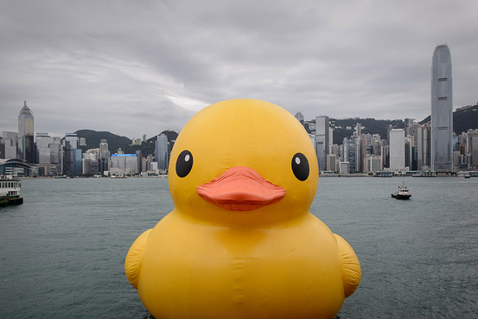

We get the picture from: <https://blogs.wsj.com/chinarealtime/2013/05/31/giant-yellow-ducks-creator-not-flattered-by-chinese-imitators/>

**Then, for each of the following, guess the effect of performing the command on the original color image, perform it, describing what you see, including anything that you did not expect, and save the image in your report.**

1. 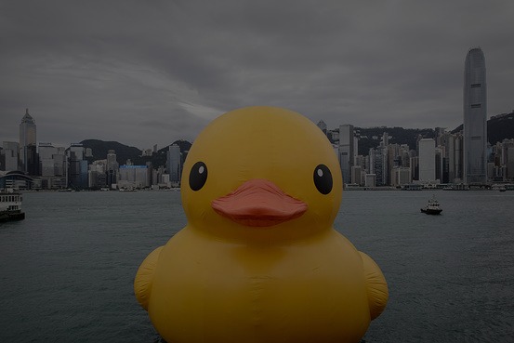Cut the values in all bands in half

Guess: We guess that this will become darker. Since all 0s are black and all 255s are white. When the number become smaller, we should get a darker number. Since everything decrease in proportion, the hue should not change much.

Actual: It becomes darker. The result is the same as we guessed.

1. 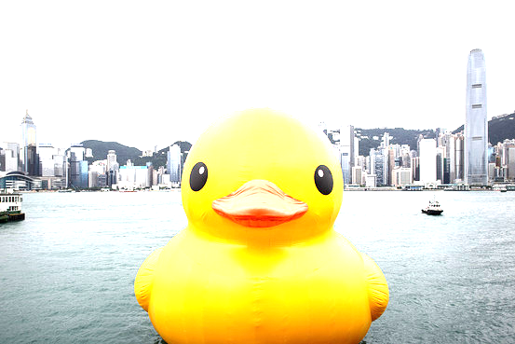Double all bands

Guess: This is similar to a, just the opposite way. So we guess it will be brighter for the same reason.

Actual: It becomes brighter. The result is the same as we guessed.

1. Exchange the green and blue bytes. What should happen to the yellow regions?

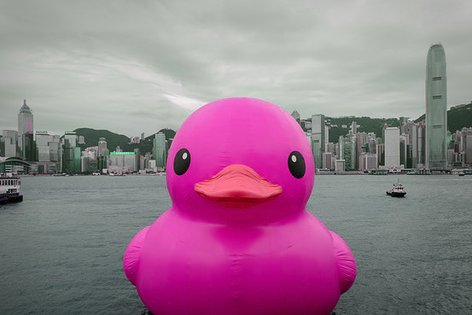

Guess: We guess that the yellow part will become magenta. Because yellow is the combination of green and red. When I change green to blue, the yellow color become the color of the combination of blue and red, which is magenta.

Actual: The yellow part in the image become magenta as we expected. Since our background is mainly grey, it does not change much. There is a few bright colors appear in the background.

1. 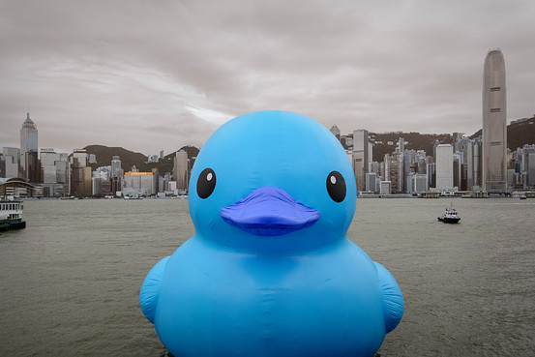Exchange the red and blue bytes. What should happen to the yellow regions?

Guess: We guess that the yellow part will become light blue. Because yellow is the combination of green and red. When I change red to blue, the yellow color become the color of the combination of green and blue, which is light blue. This similar to problem c.

Actual: We guessed correctly. The yellow part become light blue. The rest part is the same as c.

1. Double all the blue values.

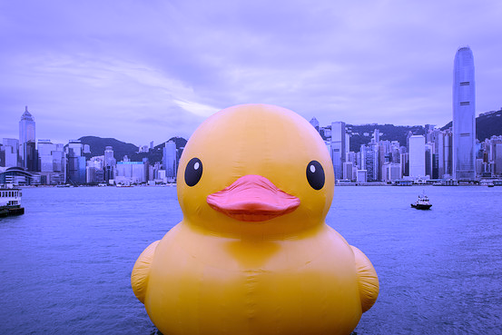

Guess: We guess the whole picture will become more "blue". The grey background will be blue. The yellow part will be more like white. Because red, green and blue give us white. How white it will be depend on the origin number of blue in it. If it was really small originally, it will have little change.

Actual: The yellow part is still yellow and the background becomes blue. This is what we expected.

**Save the histogram of the hues as an image file named hue_histogram.png. Explain the histogram.**

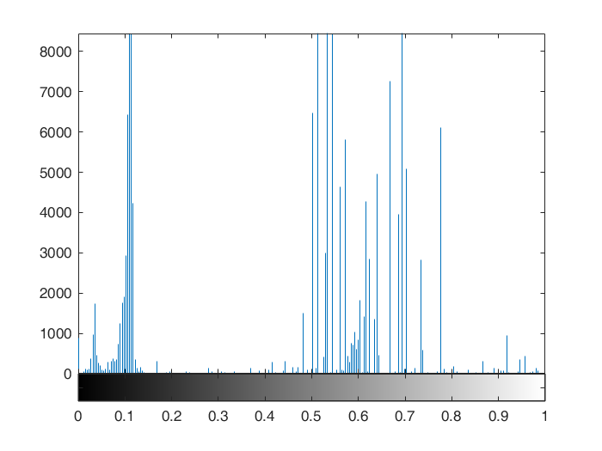

The hue histogram is a representation of color in an image. The x-axis of this image represents the tonal scale (black at the left and white at the right) and y-axis represents the number of pixels in an image in a certain area of the tonal scale. Looking at the histogram of hues and the image of hues, there are more light color space than dark color space, so there are more pixels roughly distributed from 0.5 to 0.8. There are many pixel at about 0.1. From the picture below, we can see that it should originally be yellow, which is the main object in our picture. So we have a high concentration there.

This is the picture for the hue:

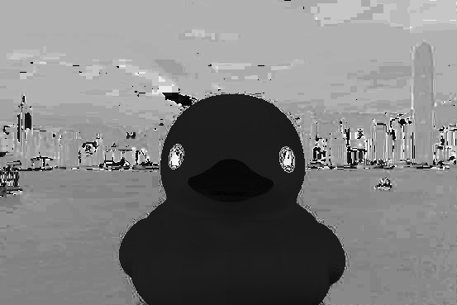

**Save the resulting binary (black and white) mask you find.**

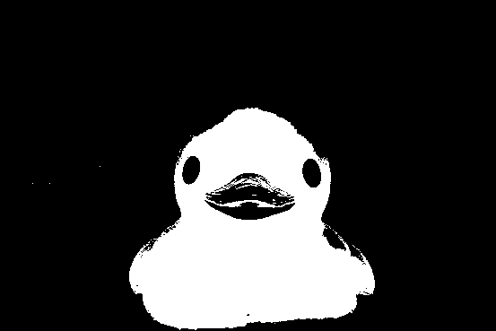

**How many pixels of that color did you find?**

40280 pixels.

**Save into your report 3 different interesting masks found by applying 3 different morphological operators to the original mask. You should use different structure elements for each of the three to see the effects of various structure elements. Additionally, the structure elements could each be a different size, but they must all be large enough where there is a visible effect on the mask.**

Dilate

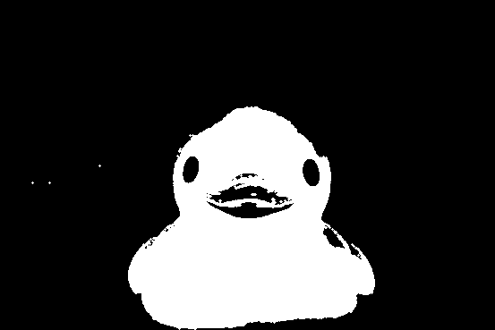

*Use dilate with 3*3 4 neighbors*

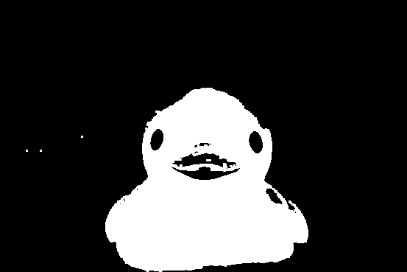

*Use dilate with 3*3 8 neighbors*

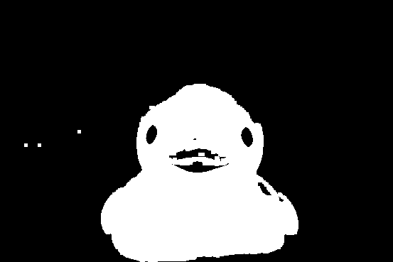

*Use dilate with 5*5 8 neighbors*

Erode

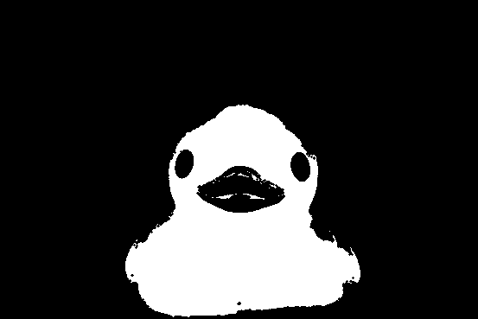

*Use erode with 3*3 4 neighbors*

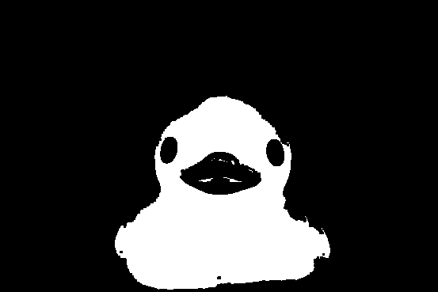

*Use erode with 3*3 8 neighbors*

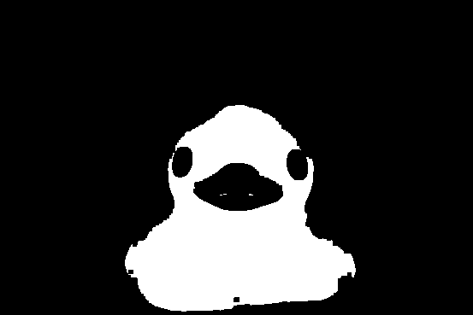

*Use erode with 5*5 8 neighbors*

Open

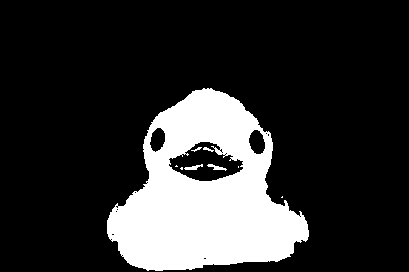

*Use open with 3*3 4 neighbors*

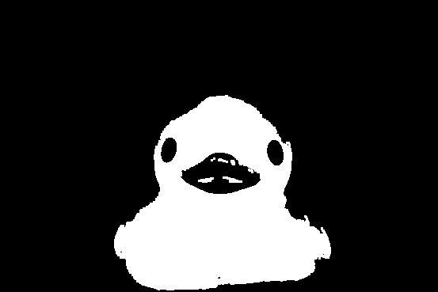

*Use open with 3*3 8 neighbors*

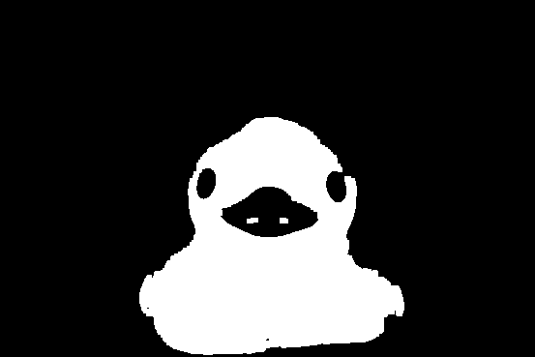

*Use open with 5*5 8 neighbors*

Close

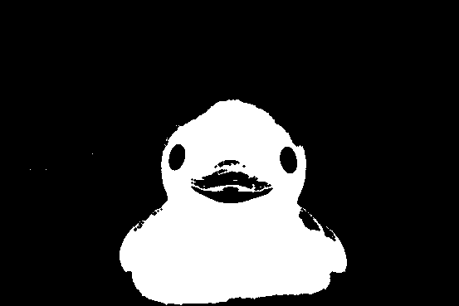

*Use close with 3*3 4 neighbors*

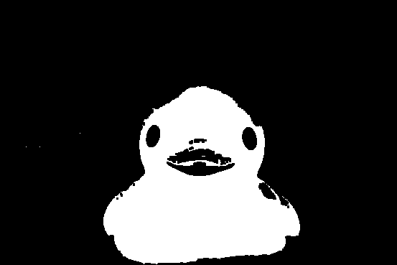

*Use close with 3*3 8 neighbors*

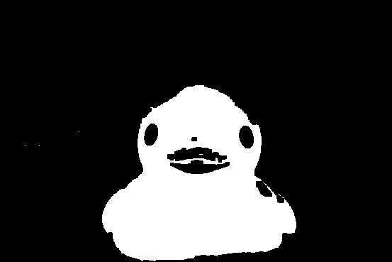

*Use close with 3*3 8 neighbors*

**Write a paragraph with the following:**

What color you tried to find

How easy or tough it was to find that color and why

The number of pixels of the color

The effect of each of the morphological operations you used, and the number of pixels in each of the 3 masks.

Since yellow is the main color that we can find in our picture, we tried to find yellow. It is not hard to find the color, because the difference between it and other background colors are quite obvious. We can find the restrictions easily by comparing the RGB value for the pixels. We get the criteria that the value for red is >120, for green is >70 and for blue is <100. Using this as filter, we find there are 40280 pixels of the color. Since our picture size is 369*553 pixels, we believe it is a quite reasonable value.

We use 3*3 with 4 neighbors, 3*3 with 8 neighbors, and 5*5 with 8 neighbors as 3 different masks and use dilate, erode, open and close as four methods to mask the image. We attached a chart for all the number of pixels we get in each method. In the dilate method, the more neighbors we choose, the more pixels we get. Because it is trying to get more. Erode is just the opposite because it is trying to erase more. So it is quite obvious that in dilate our duck is larger and in erode our duck is smaller. The mouth of the deck is another interesting part. The color of it is orange, which is kind of close to yellow. So in our filter, some of the pixels in mouth got identified as yellow. So in the dilate method. It affect more pixels around it, while in the erode method, we almost eliminate the effect, because most of the parts are black originally.

Since the open and close method combines both dilate and erode, we feel it give a better performance. Open is first erode then dilate, so the mouth part is more similar to the erode method. With the dilate, it gets more pixels then only erode it. Similar for the close method. The final result looks more like a reasonable size duck with more obvious mouth. With a larger mask, we have less noise, the difference between different method become larger, but we also throw away some details. Since we don’t know the exact amount of yellow pixels in our picture, we can’t say which one is the most accurate.

|  |  |  |  |
| --- | --- | --- | --- |
|  | 3*3 with 4 neighbors | 3*3 with 8 neighbors | 5*5 with 8 neighbors |
| dilate | 42365 | 43005 | 45058 |
| erode | 38228 | 37620 | 35786 |
| open | 39826 | 39574 | 39200 |
| close | 40661 | 40846 | 41170 |

We did some fun things with the close 3*3 with 8 neighbors mask. We make the yellow part to be 0.7, and make our background brighter.

